PIZZA SALES SQL QUERIES

This report delves into the operational and sales data of a pizza restaurant, showcasing how data scraping, organization in Excel, and SQL queries were utilized to extract valuable insights. By processing raw data into meaningful metrics, the report highlights key trends, including customer preferences, peak sales periods, and performance analysis. Below, you will find detailed visualizations and interpretations derived from the data, providing actionable insights to optimize restaurant operations and strategies.

**A. KPI’s**

**1. Total Revenue:**

SELECT SUM(total_price) AS Total_Revenue FROM pizza_sales;

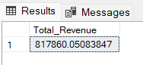

**2. Average Order Value**

SELECT (SUM(total_price) / COUNT(DISTINCT order_id)) AS Avg_order_Value FROM pizza_sales

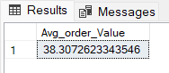

**3. Total Pizzas Sold**

SELECT SUM(quantity) AS Total_pizza_sold FROM pizza_sales

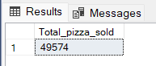

**4. Total Orders**

SELECT COUNT(DISTINCT order_id) AS Total_Orders FROM pizza_sales

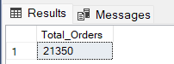

**5. Average Pizzas Per Order**

SELECT CAST(CAST(SUM(quantity) AS DECIMAL(10,2)) /

CAST(COUNT(DISTINCT order_id) AS DECIMAL(10,2)) AS DECIMAL(10,2))

AS Avg_Pizzas_per_order

FROM pizza_sales

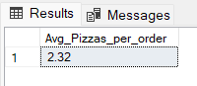

**B. Daily Trend for Total Orders**SELECT DATENAME(DW, order_date) AS order_day, COUNT(DISTINCT order_id) AS total_orders

FROM pizza_sales

GROUP BY DATENAME(DW, order_date)

***Output:***

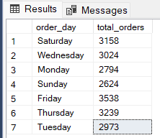

**C. Hourly Trend for Orders**

SELECT DATEPART(HOUR, order_time) as order_hours, COUNT(DISTINCT order_id) as total_orders

from pizza_sales

group by DATEPART(HOUR, order_time)

order by DATEPART(HOUR, order_time)

***Output***

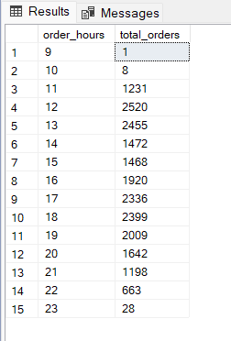

**D. % of Sales by Pizza Category**

SELECT pizza_category, CAST(SUM(total_price) AS DECIMAL(10,2)) as total_revenue,

CAST(SUM(total_price) * 100 / (SELECT SUM(total_price) from pizza_sales) AS DECIMAL(10,2)) AS PCT

FROM pizza_sales

GROUP BY pizza_category

***Output***

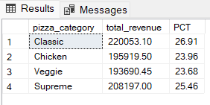

**E. % of Sales by Pizza Size**

SELECT pizza_size, CAST(SUM(total_price) AS DECIMAL(10,2)) as total_revenue,

CAST(SUM(total_price) * 100 / (SELECT SUM(total_price) from pizza_sales) AS DECIMAL(10,2)) AS PCT

FROM pizza_sales

GROUP BY pizza_size

ORDER BY pizza_size

***Output***

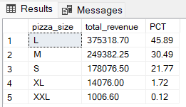

**F. Total Pizzas Sold by Pizza Category**

SELECT pizza_category, SUM(quantity) as Total_Quantity_Sold

FROM pizza_sales

WHERE MONTH(order_date) = 2

GROUP BY pizza_category

ORDER BY Total_Quantity_Sold DESC

***Output***

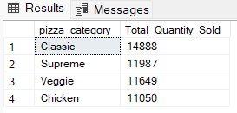

**G. Top 5 Best Sellers by Total Pizzas Sold**

SELECT Top 5 pizza_name, SUM(quantity) AS Total_Pizza_Sold

FROM pizza_sales

GROUP BY pizza_name

ORDER BY Total_Pizza_Sold DESC

***Output***

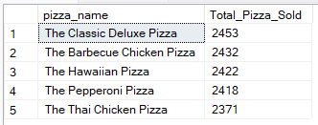

**H. Bottom 5 Best Sellers by Total Pizzas Sold**

SELECT TOP 5 pizza_name, SUM(quantity) AS Total_Pizza_Sold

FROM pizza_sales

GROUP BY pizza_name

ORDER BY Total_Pizza_Sold ASC

***Output***

